Server Health Check Script - Title
Problem Statement
Operations team requires quick health summary.
Objectives
The script reports:
- CPU usage
- Memory usage
- Disk usage
- Top resource-consuming processes
- Active network connections
- Structured health summary report

Script Implementation
- File Name - server_health.sh

Script
#!/bin/bash

# =====================================
# CONFIGURATION
# =====================================

REPORT_DIR="$HOME/health_reports"
mkdir -p "$REPORT_DIR"

TIMESTAMP=$(date '+%Y%m%d_%H%M%S')
REPORT_FILE="$REPORT_DIR/health_report_$TIMESTAMP.txt"

HOSTNAME=$(hostname)
DATE=$(date '+%Y-%m-%d %H:%M:%S')

# =====================================
# REPORT HEADER
# =====================================

echo "=====================================" >> "$REPORT_FILE"
echo "SERVER HEALTH REPORT" >> "$REPORT_FILE"
echo "=====================================" >> "$REPORT_FILE"
echo "Host: $HOSTNAME" >> "$REPORT_FILE"
echo "Generated: $DATE" >> "$REPORT_FILE"
echo "" >> "$REPORT_FILE"

# =====================================
# CPU USAGE
# =====================================

echo "----- CPU Usage -----" >> "$REPORT_FILE"
top -bn1 | grep "Cpu(s)" >> "$REPORT_FILE"
echo "" >> "$REPORT_FILE"

# =====================================
# MEMORY USAGE
# =====================================

echo "----- Memory Usage -----" >> "$REPORT_FILE"
free -h >> "$REPORT_FILE"
echo "" >> "$REPORT_FILE"

# =====================================
# DISK USAGE
# =====================================

echo "----- Disk Usage -----" >> "$REPORT_FILE"
df -h >> "$REPORT_FILE"
echo "" >> "$REPORT_FILE"

# =====================================
# TOP PROCESSES
# =====================================

echo "----- Top 5 Processes (by CPU) -----" >> "$REPORT_FILE"
ps -eo pid,ppid,cmd,%mem,%cpu --sort=-%cpu | head -6 >> "$REPORT_FILE"
echo "" >> "$REPORT_FILE"

echo "----- Top 5 Processes (by Memory) -----" >> "$REPORT_FILE"
ps -eo pid,ppid,cmd,%mem,%cpu --sort=-%mem | head -6 >> "$REPORT_FILE"
echo "" >> "$REPORT_FILE"

# =====================================
# NETWORK CONNECTIONS
# =====================================

echo "----- Active Network Connections -----" >> "$REPORT_FILE"
ss -tunap | head -20 >> "$REPORT_FILE"
echo "" >> "$REPORT_FILE"

# =====================================
# REPORT COMPLETE
# =====================================

echo "Report saved at: $REPORT_FILE"
Sample Output
Report saved at: /home/user/health_reports/health_report_YYYYMMDD_HHMMSS.txt

View Report
cat ~/health_reports/health_report_*.txt
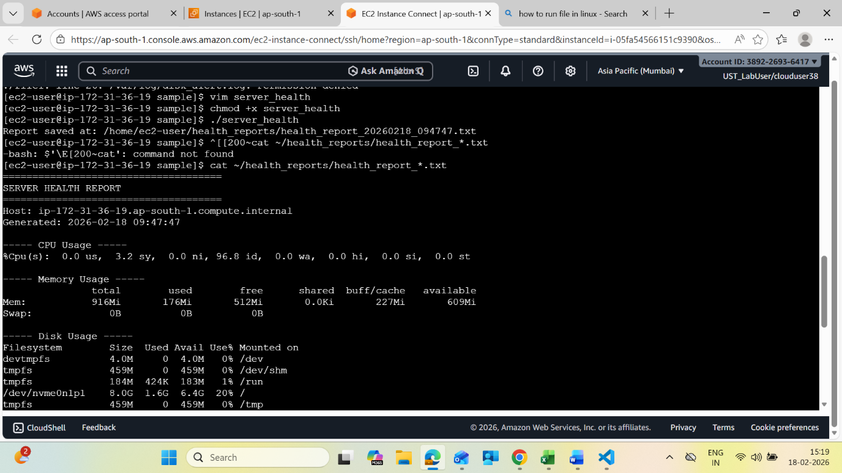

Conclusion
This script provides a structured snapshot of server health by aggregating key performance indicators into a single report. It supports quick diagnostics and operational monitoring.
Work flow
Start script
↓
Create report directory
↓
Create timestamped report file
↓
Collect CPU usage
↓
Collect memory usage
↓
Collect disk usage
↓
Identify top processes
↓
Capture network connections
↓
Write structured report
↓
Display report path
↓
End

